2018 CARO AGM
hosted by KAOS Dogsports Inc.

Limited Edition Merchandise Order Form
We have chosen high quality products that we hope will last you for many years to come: ATC, Bella Canvas and Coal Harbour. Payments must be made, in full, at time of order. Shipping available upon request.
Neither, CARO nor KAOS Dogsports Inc., will be purchasing extra items, for future purchase.
You must order them by MARCH 20, 2018.
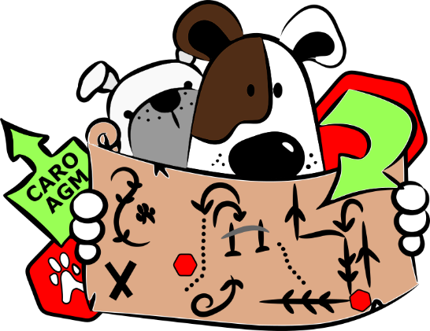
2018 CARO AGM T-Shirt  Artwork by Natasha Mathews,  CARO Judge & SK/MB Board Of Director | KAOS 2018 CARO AGM Trial T-Shirt

KAOS Dogsports 2018CARO AGM Rally-O T-Shirts!
$25 each
Fit Guide at: https://www.bellacanvas.com/product/3001/Unisex-Jersey-Short-Sleeve-Tee.html

DESIGN OPTIONS  Bella Canvas 3001 T-Shirt. | COLOUR OPTIONS |  | QUANTITY ORDERING  (Indicate Qty next to each size ordering.) |  | TOTALS
IMAGE ON BACK  ON FRONT:  KAOS CARO 2018 AGM | ATHLETIC GREY  Ath. Heather - 90% Airlume combed and ring-spun cotton, 10% poly |  | XS ___________# shirts ordered  S ___________# shirts ordered  M ___________# shirts ordered  L ___________# shirts ordered  XL ___________# shirts ordered  2X ___________# shirts ordered  3X ___________# shirts ordered  4X ___________# shirts ordered |  | $25/shirt x _____# of shirts =  $______________
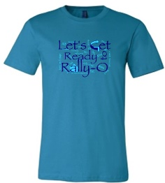 | TEAL  100% Airlume combed and ring-spun cotton, 32 single 4.2 oz. (Ash - 99% Airlume combed and ring-spun cotton, 1% poly |  | XS ___________# shirts ordered  S ___________# shirts ordered  M ___________# shirts ordered  L ___________# shirts ordered  XL ___________# shirts ordered  2X ___________# shirts ordered  3X ___________# shirts ordered  4X ___________# shirts ordered |  | $25/shirt x _____# of shirts =  $______________
CARO Merchandise
DESIGN OPTIONS |  | COLOUR OPTIONS |  | SIZE & QUANTITIES |  | TOTALS
POLO SHIRT  w/ Embroidered CARO Logo  - 8.4-oz, 65/35 polyester/cotton pique; Soil release treatment will remove most stains when washed; Rib knit collar; Anti-pill; Tagless  Size guide:  http://www.sanmarcanada.com/specsheets/CH_S4022.pdf |  | WHITE |  | XS ___________# shirts ordered  S ___________# shirts ordered  M ___________# shirts ordered  L ___________# shirts ordered  XL ___________# shirts ordered  2X ___________# shirts ordered  3X ___________# shirts ordered  4X ___________# shirts ordered |  | $22.20/shirt x _____# of shirts =  $______________
 |  | ROYAL |  | XS ___________# shirts ordered  S ___________# shirts ordered  M ___________# shirts ordered  L ___________# shirts ordered  XL ___________# shirts ordered  2X ___________# shirts ordered  3X ___________# shirts ordered  4X ___________# shirts ordered |  | $22.20/shirt x _____# of shirts =  $______________
 |  | BLACK |  | XS ___________# shirts ordered  S ___________# shirts ordered  M ___________# shirts ordered  L ___________# shirts ordered  XL ___________# shirts ordered  2X ___________# shirts ordered  3X ___________# shirts ordered  4X ___________# shirts ordered |  | $22.20/shirt x _____# of shirts =  $______________
BUNNY HUG  AKA HOODIE  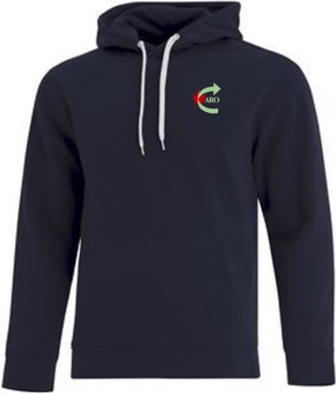  w/ Embroidered CARO Logo  - 15.7-oz, 75/25 cotton/polyester fleece; Combed and ring spun cotton; 100% cotton jersey lined hood with contrast drawstring; Tear away label; Superior printing surface;*60/40 cotton/polyester; **95/5 cotton/viscose |  | 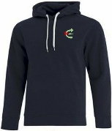  NAVY |  | XS ___________# shirts ordered  S ___________# shirts ordered  M ___________# shirts ordered  L ___________# shirts ordered  XL ___________# shirts ordered  2X ___________# shirts ordered  3X ___________# shirts ordered  4X ___________# shirts ordered |  | $29.97/shirts x _____# of shirts =  $______________
 |  | ATHLETIC GREY |  | XS ___________# shirts ordered  S ___________# shirts ordered  M ___________# shirts ordered  L ___________# shirts ordered  XL ___________# shirts ordered  2X ___________# shirts ordered  3X ___________# shirts ordered  4X ___________# shirts ordered  Size guide: http://www.sanmarcanada.com/specsheets/ATC_F2016.pdf |  | $29.97/shirts x _____# of shirts =  $______________
TOTE BAGS |  | QUANTITY & TOTALS
14.87” x 5.12” x 12.75” |  | $16.65/tote x _____# of totes =  $______________
14.87” x 5.12” x 12.75” |  | $16.65/tote x _____# of totes =  $______________
Email forms to rally@kaosdogsports.ca or  mail to 1311 Ottawa St, Regina, SK, S4P 1P3 |  |  |  |  |  | TOTAL AMOUNT DUE: | $

PAYMENT: CASH, MONEY ORDER, CHEQUE or
EMAIL TRANSFER to rally@kaosdogsports.ca
Orders will be available for pick up at the 2018 CARO AGM at KAOS Dogsports, Regina, SK

We will accept orders that require shipping. They will be shipped AFTER the AGM. Your shipping fee determined once we receive your order and have a total weight and size. Shipping fees must be paid prior to being sent.

Name: |  |  |  | Email:
Mailing Address: |  |  |  | City: |  |  |  | Prov
Postal Code:
Home Phone: |  |  |  | Cell Phone:

